实现的效果

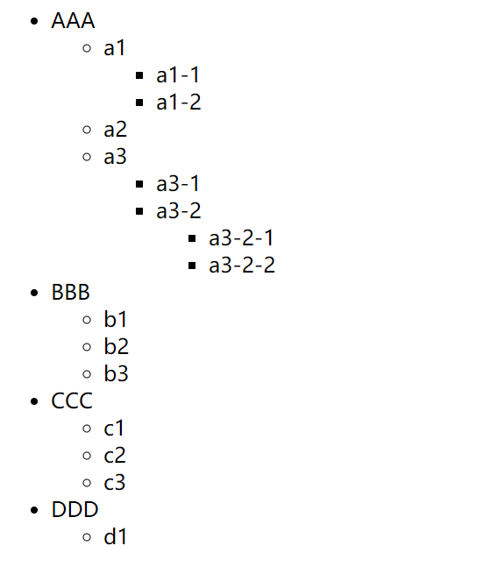

数据格式

var data = [

{

name:'AAA',

child:[

{name:'a1',child:[{name:'a1-1'},{name:'a1-2'}]},

{name:'a2'},

{name:'a3',child:[{name:'a3-1'},{name:'a3-2',child:[{name:'a3-2-1'},{name:'a3-2-2'}]}]}

]

},

{

name:'BBB',

child:[{name:'b1'},{name:'b2'},{name:'b3'}]

},

{

name:'CCC',

child:[{name:'c1'},{name:'c2'},{name:'c3'}]

},

{

name:'DDD',

child:[{name:'d1'}]

}

];